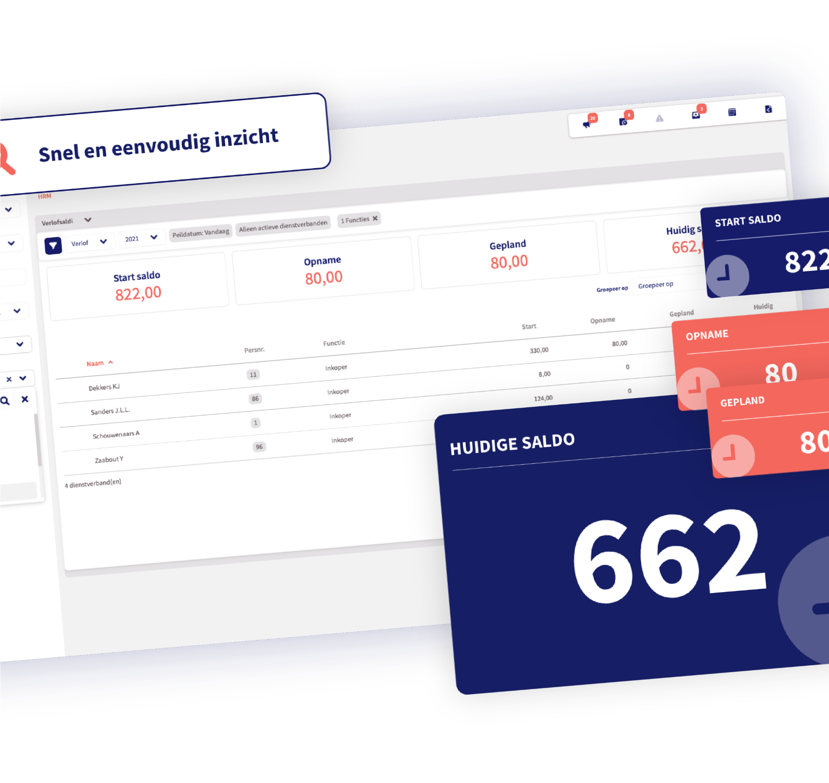

Loket.nl User’s Guide
Discover the application

Loket.nl User’s Guide

In this guide we will take you through the operation of Loket.nl. We will run through the basics that you as an employer want to know.

Log in

Logging in to Loket.nl is very easy. You navigate to: https://login.loket.nl/ and log in with your username and password. Do you have a shortcut to the URL that still links to Loket.nl Classic or did you have this URL saved as a favourite? Then change
the old URL to: https://login.loket.nl

Something on the Loket.nl login page immediately catches your eye: the chapta is missing. This makes it even easier and quicker for you as a user to log in. It goes without saying that this was realised without loss of safety standards. We are still working together with Trust Guard, which ensures the security and robustness of the application as you are used to from Loket.nl.

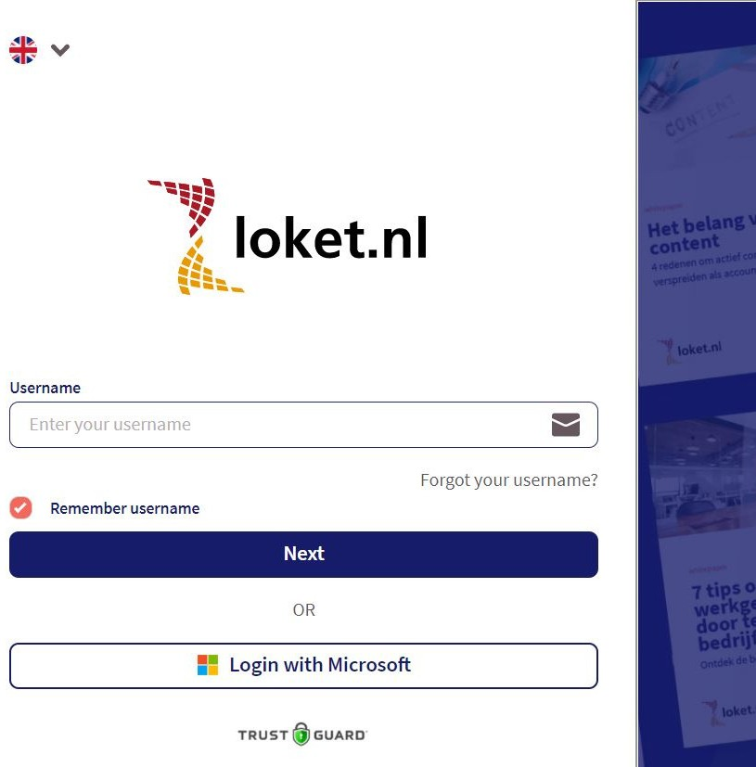

Forgot your username?
Have you, for whatever reason, forgotten your username? Then on the login page of Loket.nl, you can select the option to indicate that you have forgotten your username. When you click on it you will see the following screen. If you provide your registered email address, an email with your username will be sent to this email address.

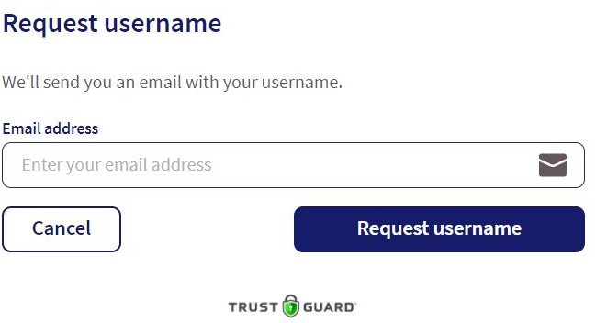

Forgotten your password?
In order to log in, you must enter your password after you have entered your username. If you cannot remember your password, click on Forgot your password? in this window. You will then see the below screen. If you enter your username, an email will be sent to the related email address, containing instructions on how to choose a new password.

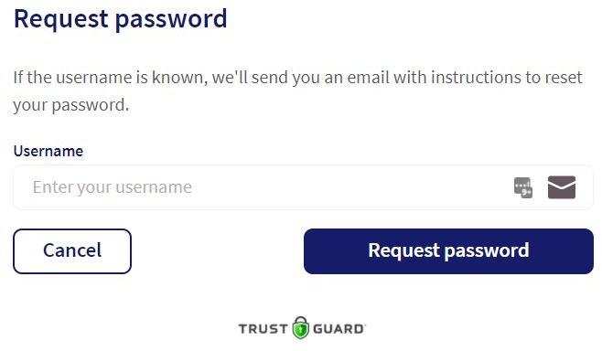

Settings

After logging in to Loket.nl, you will find the cogwheel icon at the bottom left with the description Settings.
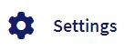

If you click on this you can change a number of settings. These include the following:
Languages: Dutch, English or German.
Explanation: This will open an additional tab in your browser containing the Loket.nl helpdesk portal.
Loket.nl Classic: This allows you to easily switch back to the previous version of Loket.nl.
2 factor authentication: This allows you to add additional security to your account by means of an extra verification code

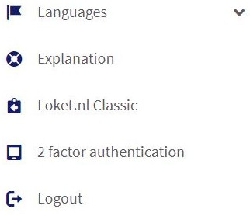

Navigating in Loket.nl

The design of the latest Loket.nl is completely responsive. This means that the layout of the screen automatically adapts to the type of screen you are using. Whether you are using a laptop, tablet or mobile phone: Loket.nl can be used on any device.

Structure:
Loket.nl uses two types of menu items. The main menus are on the left of the screen. The main menu has several submenus. See the example below of the main menu Payroll , including the submenus Payroll runs, Tax returns, and Journal runs.

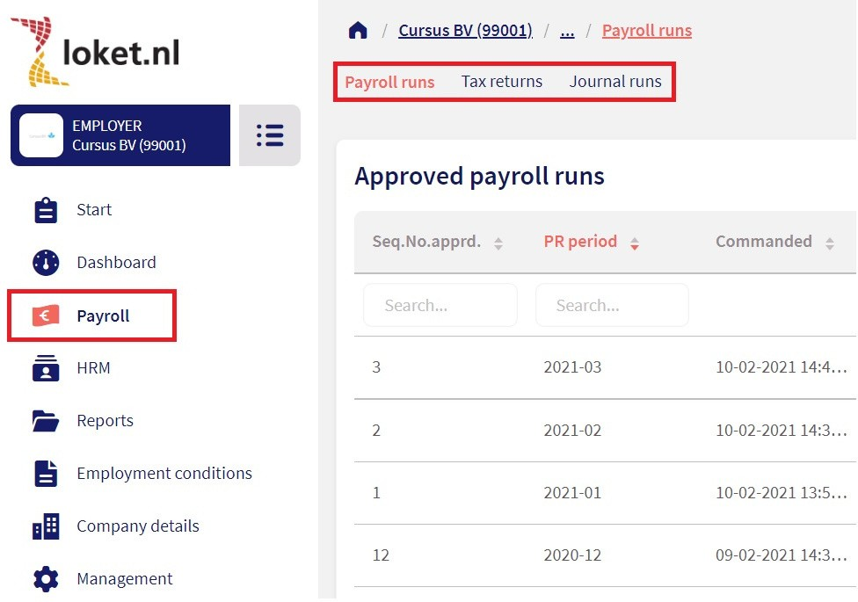

Selection screens:
There are two different screens within Loket.nl:

Selection screens Entry screens

An example of the selection screen is the possibility to select an employer.
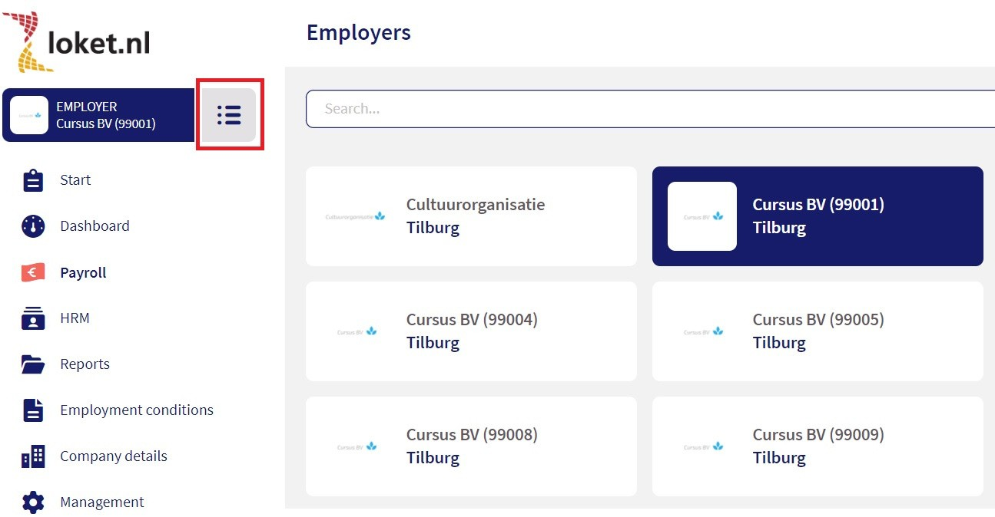
Do you want to add or modify data? Entry screens offer the possibility of adding or modifying data. With the plus sign you can add (or enter) data.

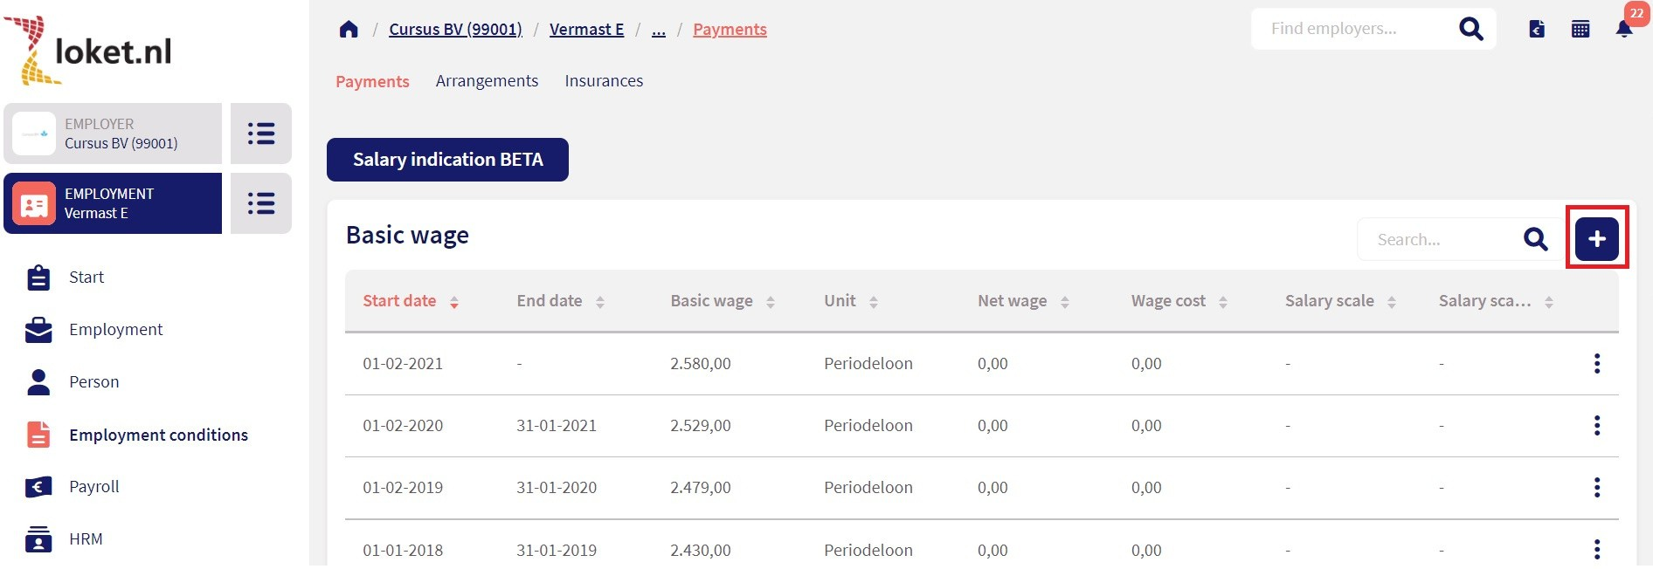

If you want to modify data, click on an existing line and select modify. Do you want to delete a line previously entered? Then click on the bin.
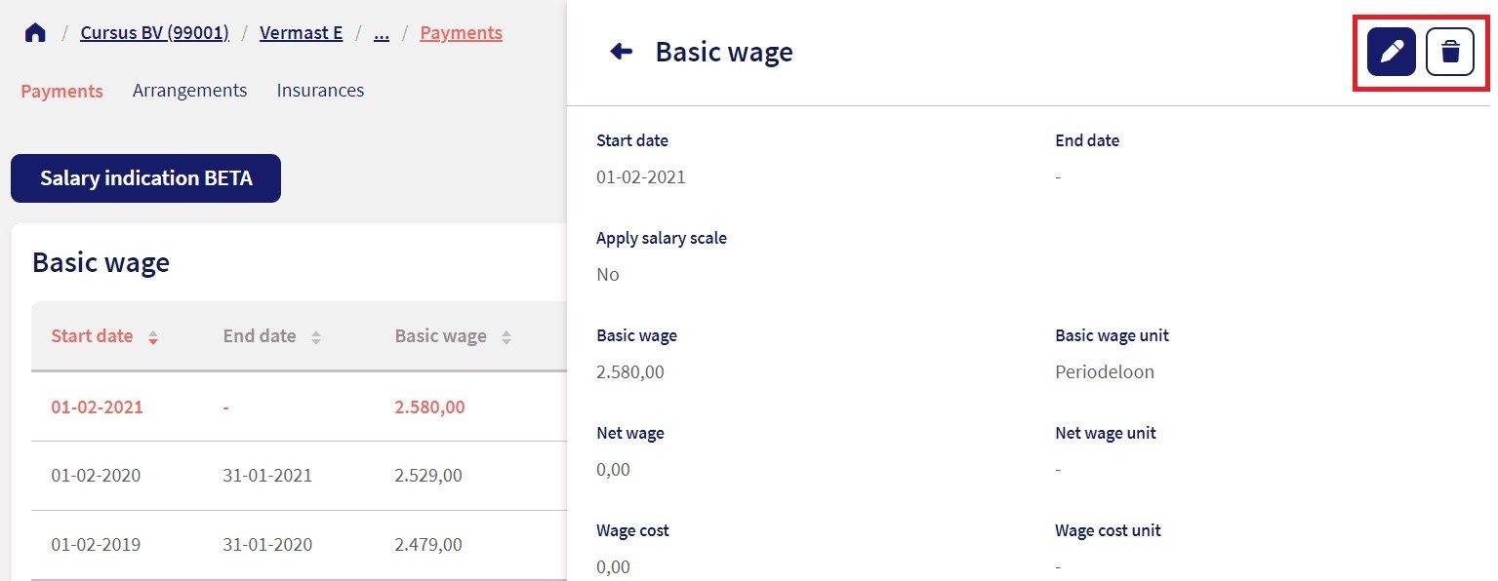

Navigation buttons:
Do you want to navigate between employees and maintain the same screen? No problem. You can do this by using the navigation buttons next to the employee (see the screenshot below). Do you have access to multiple employers? Then you can also navigate between employers with the navigation buttons.
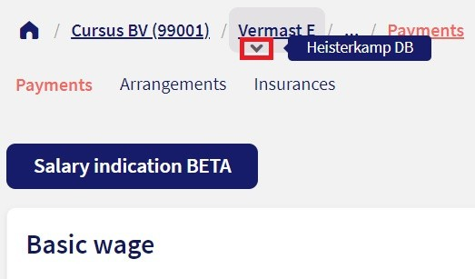
Depending on the rights and products you have access to, you can use the buttons on the side to navigate. The selected employer is at the top. Do you have access to multiple employers? Then you can select them by clicking on the three bars.
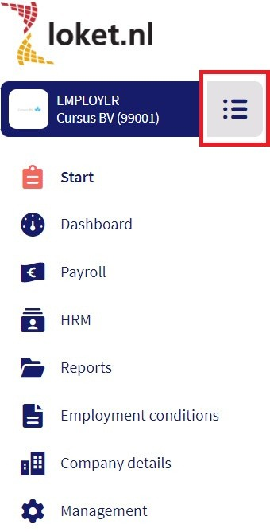

Filtering:
A new feature in Loket.nl is the possibility to filter employment contracts by active employment contract/inactive employment contract and/or to filter by department. This filtering is currently applied to the Browser variable data and the Calendar. Of course we will offer more fields for filtering in the future.
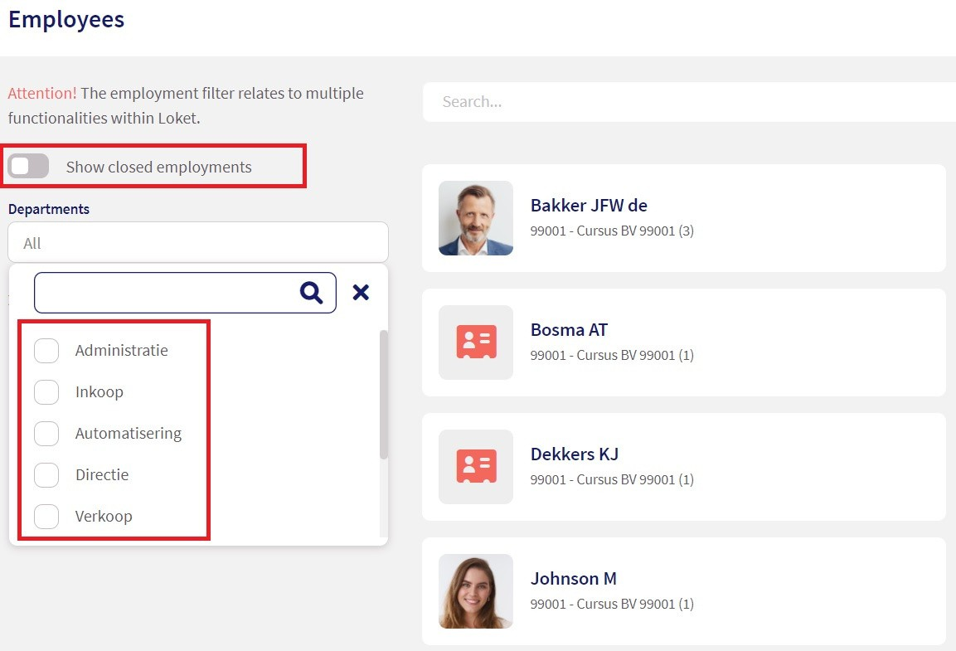

Is there a filter active? A dot will then be shown in the list of employment contracts
button.
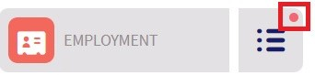

Overview page

The overview page of the selected employer is also called the start page of the employer. The navigation buttons are listed on the left and various items, such as new employee, payroll processing status, and birthdays are listed on the right of this start page. We would like to take you through the items visible on the right of the start page of the employer first. Then we will zoom in on the navigation buttons on the left.

Right side of the start page

New employee:
Use this button to go through the new employee wizard. In six steps you can easily add an employee.
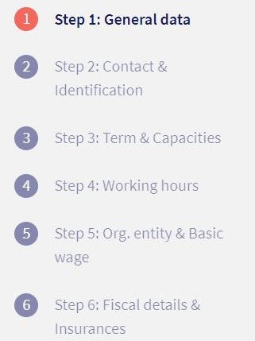

Export data:
Do you want to be able to consult many data? And to be able to filter many data? To create your own customised export? Then we have the option Export Data for you. This option will ensure more depth and breadth for further HR analysis in the future.
Through Export data you can make a filter of the personal data of the employee you wish to view and create an export file of this data.

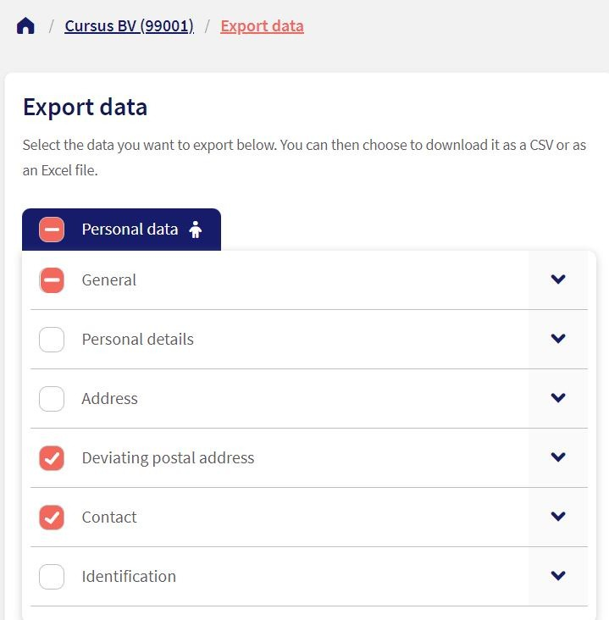

Download employer file:
On the overview page there is the option for the employer to click on the Download employer file button. If you, as a user, have the right to Download employer data and to use the product Download employer data(1060), you are permitted to retrieve a file containing many employer and employment contract data. This is useful as input for example on your dashboard. Use the option Submit request to start downloading the data for the selected year. As the overview may contain many data, this process will not be completed immediately. Your request is being processed, please continue with other business in Loket.nl. As soon as the download is completed you as a user will receive an email. You can then download the files in Loket.nl. After you have selected Download, a file with extension .rar will appear. You can open this file with a ZIP programme and a number of CSV files will appear based on subject. From here you can use all data.
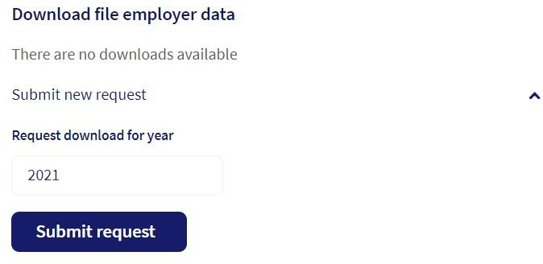

Last status of payroll processes:
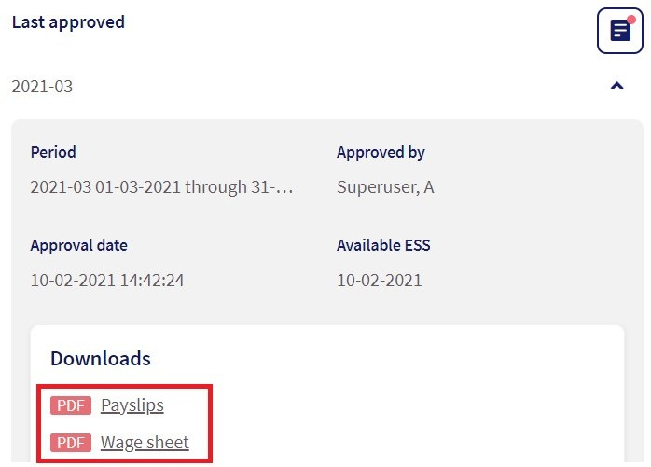
The status of the last payroll run, tax return, pension declaration and exported journal run are located further right on the screen. Just push the button to go to these items. The overviews and downloads can also be downloaded from this page.
Under the heading Tax returns you can now also very easily pay the tax return with iDEAL.
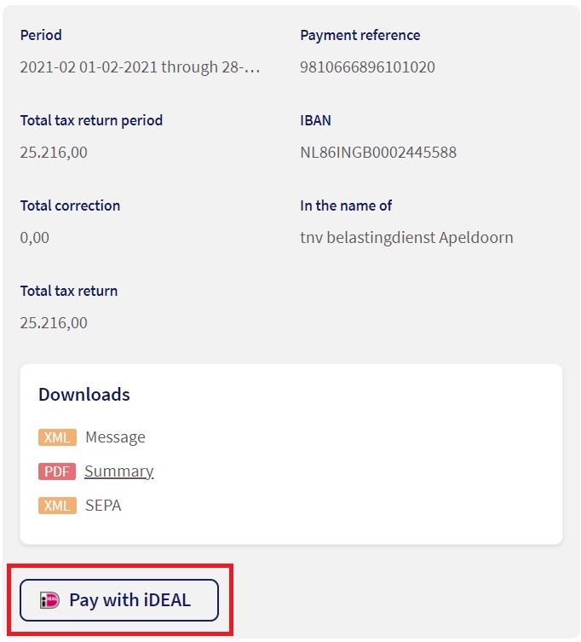

Birthday widget and Absence widget:
You will also find the Birthday widget and Absence widget on this page. Did you know that it is also possible to have a gift (such as flowers or chocolates) delivered automatically to the employee on his or her birthday? This is possible because Loket.nl and Fleurtjedag are linked. The accounting firm or administration office can provide more information about this.
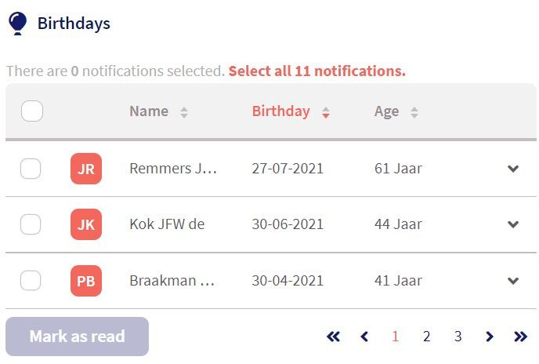

Navigation buttons on the left side of the home page

Payroll runs:
The Payroll runs tab takes you to the employer's payroll processing area. Here you will find the wage carousel, the already approved payroll runs, tax returns, and the exported journal runs.

Via the Payroll runs tab you can use a bell in the wage carousel to indicate that you have finished making changes for a specific period of time. In this way you can let the payroll administrator know that all data are ready for payroll processing. This can also be done for the previous period for which payment was already made. After all, additional processing may still be required.
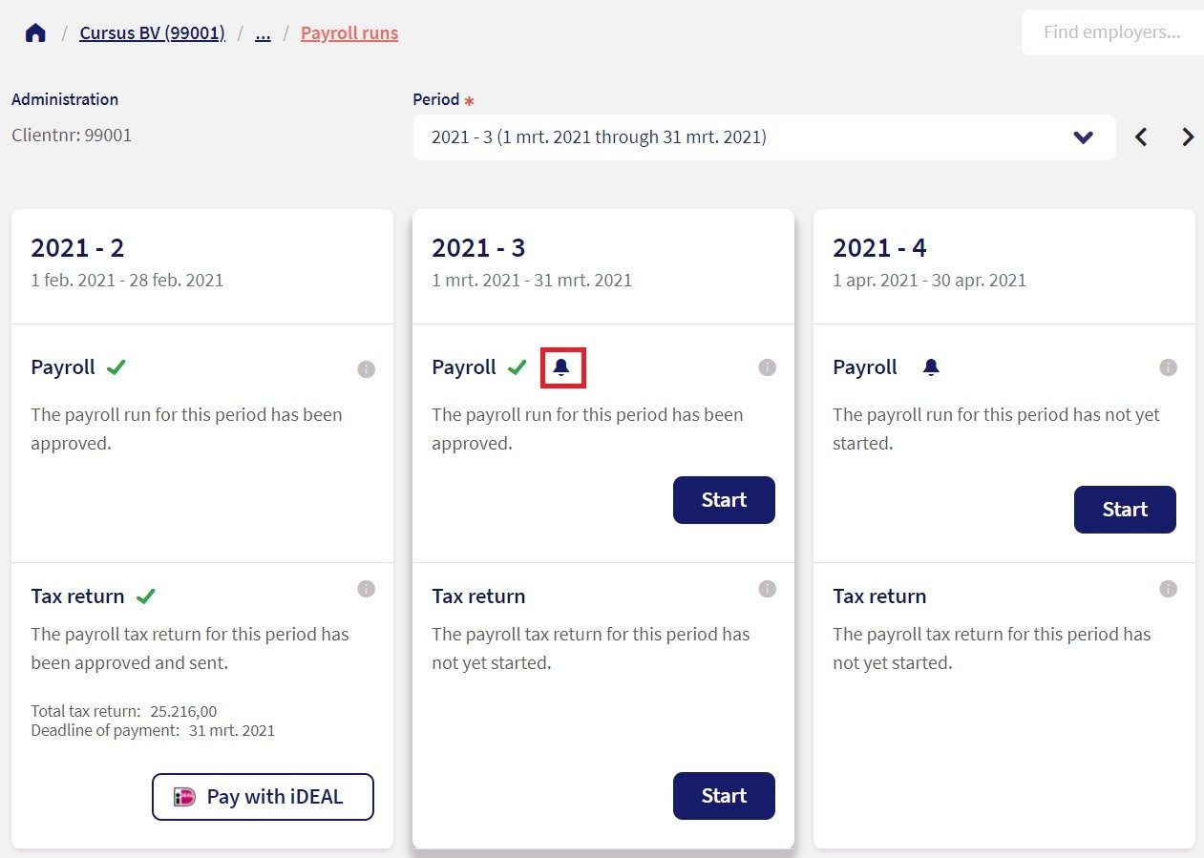

As soon as you click on this bell, the screen displayed in the below screen will appear. In this screen an email address can be entered or a default email address will be shown. Your accountancy firm or administration office has more than likely already entered a default email address for you here. Enter additional comments in the Comment field.
This comment will then also be added to the corresponding email to be sent to the accountancy firm or administration office.

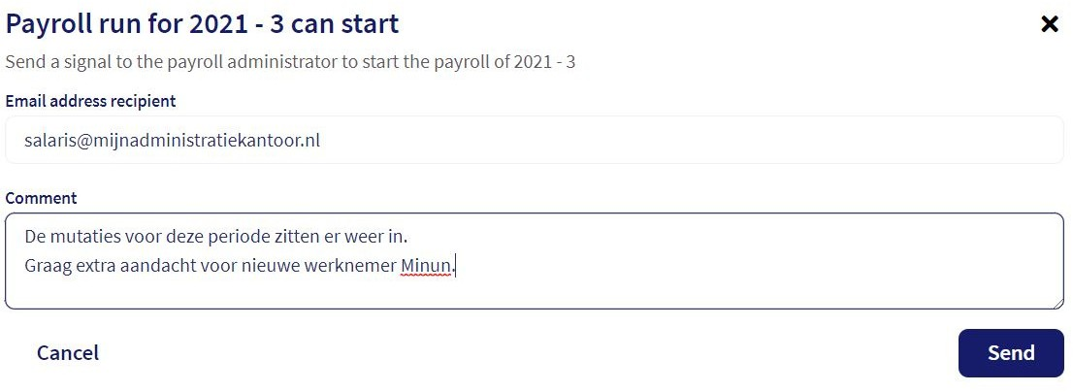

HRM:
You can find the Employer file, Documentation (or templates for being able to automatically generate documents) and Draft employees under HRM.

Reports:
We currently have a Basic report on leave, but we will continue to add more reports in the future. The term Basic has nothing to do with the skill of the user, but with the options and possibilities of the report. The report on leave is located under Reports.
When you have put on your filter you can create an export in CSV or in Excel. This way you can modify the files even more.

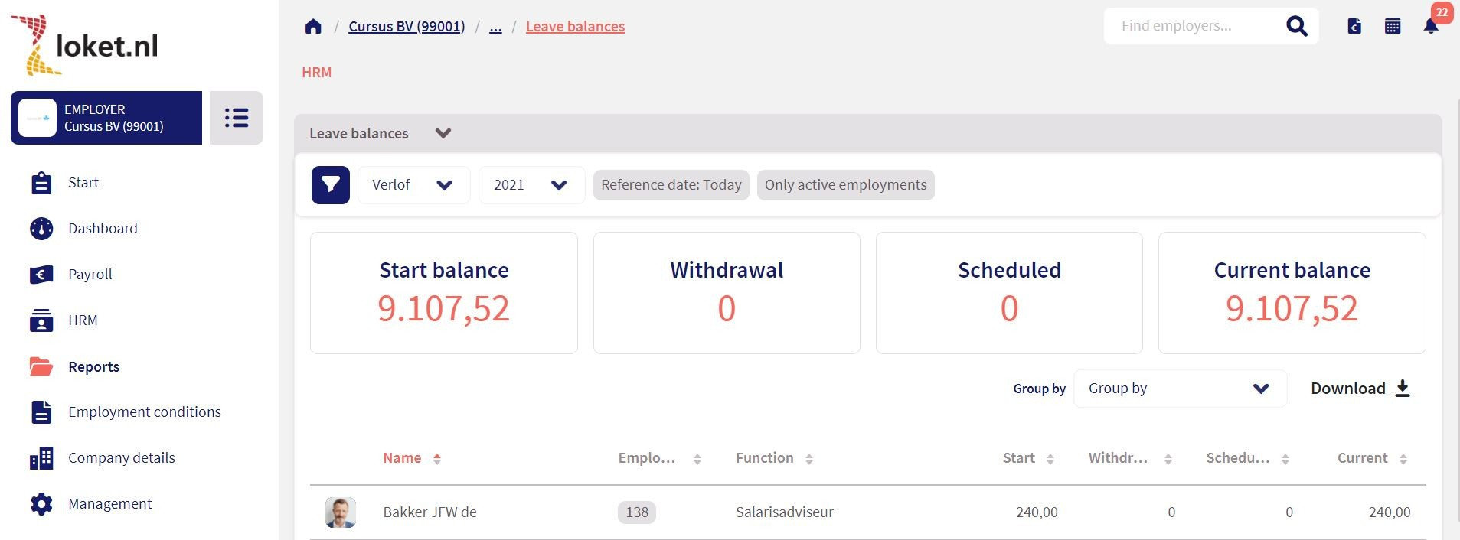

Terms of employment:
Under Terms of employment you can record the options for Provisions and create
Leave arrangements.

Company details:
In Company details you can view all of your company’s contact details and modify them if you have authority to do so.

Management:
In Management you can manage the different tables, manage email texts and view and modify Workflows .
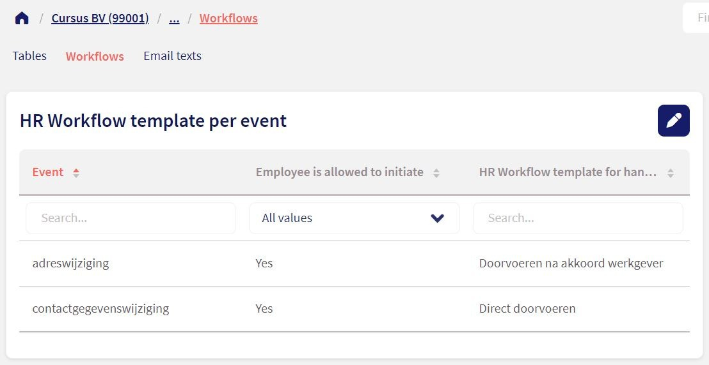

Duty centre

The Duty centre is located top right in the application. The Duty centre contains icons that are also located on the employer start page. Is there an icon with a notification in the Duty centre? Then there is a 'task' waiting for you (also called outstanding action), for example, a declaration filed or an outstanding leave request. Below we will take you through all icons of the Duty centre.

What does each icon mean?

This is the button for the outstanding alerts. These can be read and addressed here.

The outstanding leave requests are located here, they can be approved or rejected here.

The changes initiated by the employee (workflows) are located here.

The Declarations can be viewed and addressed here.

With this button you can open the calendar. Here you can see who is on leave, sick or working according to the schedule and you can select the period in which you want to see this data. The legend is below the calendar .

With this you open the Browser variable data. For payroll processing, you can choose to enter the variables for each separate employee. But the Browser variable data works much more efficiently. Input is saved intermediately and you can enter all employee variables at once.

The below screenshot shows the screen of the Browser variable data in which you can enter variables for each separate employee.
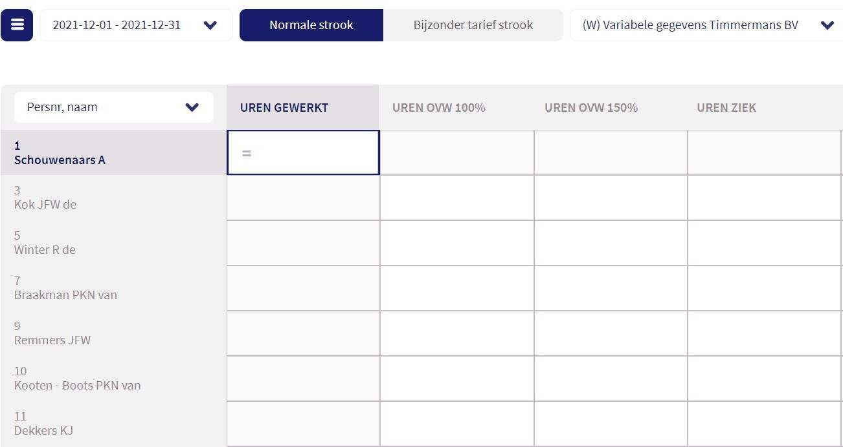

HR Dashboard

The HR Dashboard in Loket.nl provides direct insight into the key KPIs regarding wage and HR. Personnel costs are the highest cost item for many companies, but there remains a lack of insight.

The HR Dashboard is a convenient tool that brings together all the important KPIs in this area. This concerns information about labour costs, the value of outstanding leave, but also short, medium and long-term sick leave.

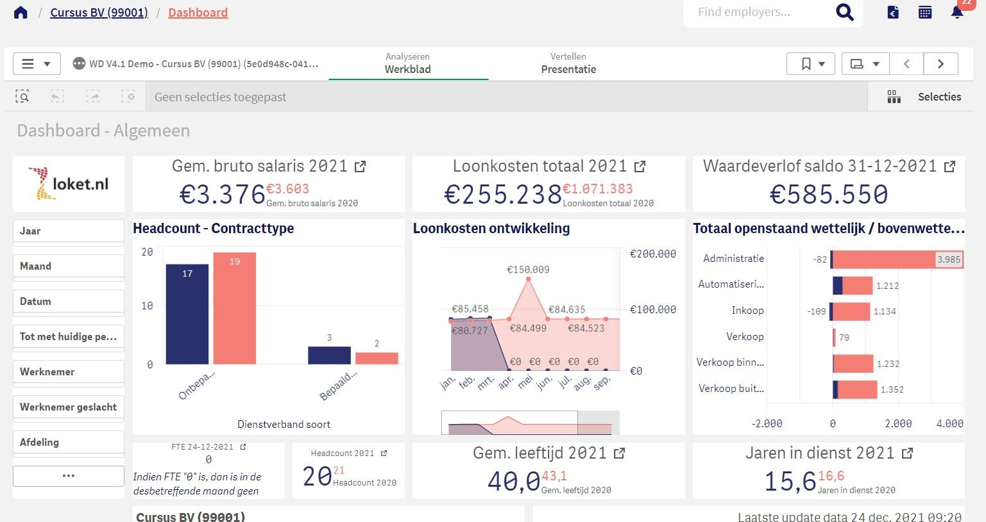

Employee level (Employment contract level)

The related tabs have been moved from the top of the screen to the left of the menu. The navigation has remained the same as much as possible for ease of use.

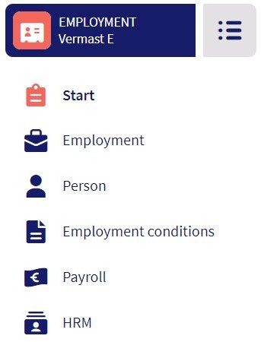

Overview page:
On the overview page you will find a collection of the most useful information you would like to be displayed of an employee. For example, this page shows the outstanding actions (signals, leave requests, declarations), the employee's wage development, remaining leave and the option to give the employee access to the Employee Desk. Good to know: nothing will change for the employee as a result of this transition to Loket.nl!

The other tabs are (almost) the same regarding their contents as in Loket.nl Classic. But we have made some smart changes in some places. We are happy to list them for you.

Benefits and deductions
This screen is located in the Employment terms tab . Previously, the screen provided a breakdown of the various benefits and deductions from gross and net wages. In Loket.nl we have put together all benefits on one screen and added convenient filters that allow you to filter out, among other things, closed fixed benefits/deductions.
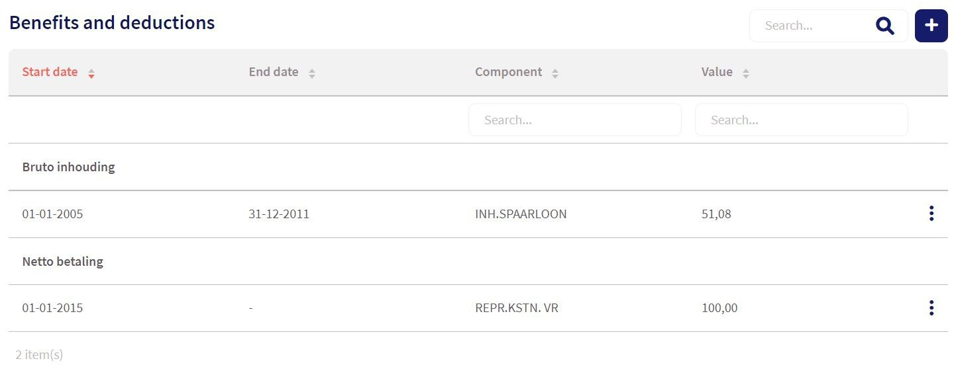

Sequence of digital signatures
If you use the digital file in Loket.nl, it is also possible to submit files for digital signature. This is not a new feature, as it was already used within Loket.nl Classic. However, in Loket.nl we have added the option to have the digital signing take place in a specific order. Not all signers are asked to sign at once in this way. See the screenshot on the next page.

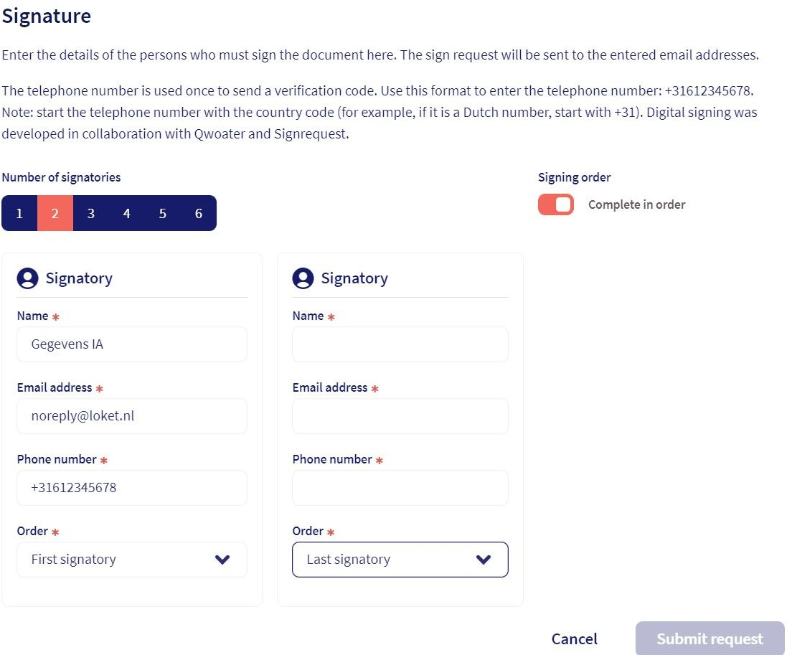

Send signal when adding documents
In Loket.nl you can have a signal (email) sent to the employee when a document is added to his or her file, when a document is added to the Employer's file and when a document is (collectively) generated.

